**Dạng 1**

1. Suppose that X is a continuous random variable whose probability **density function** is given by [[f(x)=C(4x-2x^2),0<x<2](https://cmshn.fpt.edu.vn/filter/tex/displaytex.php?texexp=f%28x%29%3DC%284x-2x%5E2%29%2C0%3Cx%3C2)](https://cmshn.fpt.edu.vn/filter/tex/displaytex.php?texexp=f%28x%29%3DC%284x-2x%5E2%29%2C0%3Cx%3C2" \o "TeX)and [[f(x)=0](https://cmshn.fpt.edu.vn/filter/tex/displaytex.php?texexp=f%28x%29%3D0)](https://cmshn.fpt.edu.vn/filter/tex/displaytex.php?texexp=f%28x%29%3D0" \o "TeX)for other values of [[x.](https://cmshn.fpt.edu.vn/filter/tex/displaytex.php?texexp=x.)](https://cmshn.fpt.edu.vn/filter/tex/displaytex.php?texexp=x." \o "TeX)What is the value of C?

Select one:

a. 0.125

b. 2.500

c. 1.520

d. 0.375

**Lấy đáp án thay vào c và tính tích phân sao cho bằng = 1**

1. Suppose the **cumulative distribution** function of the random variable X is  
     
   [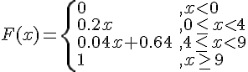](https://cmshn.fpt.edu.vn/filter/tex/displaytex.php?texexp=F%28x%29%3D%5Cleft%5C%7B%20%5Cbegin%7Barray%7D%7Bll%7D%200%20%26%2C%20x%3C0%20%5C%5C%200.2x%26%2C0%5Cleq%20x%3C4%5C%5C0.04x%2B0.64%26%2C%204%5Cleq%20x%3C9%5C%5C1%26%2Cx%5Cgeq%209%20%5Cend%7Barray%7D%20%5Cright.)  
     
   Find the value of P(X>5).

Select one:

a. 0.16

b. 1.00

c. 0.32

d. 0.84

**P(x>5) = 1-P(x<=5) = 1-(0.04*5+0.64) = 0.16**

1. The **cumulative distribution** function of a random variable *X* is given by  
   [F(x)=\left\{ \begin{array}{ll} 0 &, x<0 \\ 1-e^{-3x}&,x\geq 0 \end{array} \right.](https://cmshn.fpt.edu.vn/filter/tex/displaytex.php?texexp=F%28x%29%3D%5Cleft%5C%7B%20%5Cbegin%7Barray%7D%7Bll%7D%200%20%26%2C%20x%3C0%20%5C%5C%201-e%5E%7B-3x%7D%26%2Cx%5Cgeq%200%20%5Cend%7Barray%7D%20%5Cright.)  
     
   What is the value of the probability density function at *x* = 1?

Select one:

a. 0.05

b. 0.95

c. 0.15

d. 0.85

**P(x<=1)= 0.95 nhưng đáp án là 0.15, nếu nó hỏi lớn hơn 1 thì mới là 1-p(x<=1) chứ nhỉ???**

1. The number of hours you spend looking at YouTube on a typical Saturday night is distributed according to the **density function** [[f(x) = 2xe^{-x^2}](https://cmshn.fpt.edu.vn/filter/tex/displaytex.php?texexp=f%28x%29%20%3D%202xe%5E%7B-x%5E2%7D)](https://cmshn.fpt.edu.vn/filter/tex/displaytex.php?texexp=f%28x%29%20%3D%202xe%5E%7B-x%5E2%7D" \o "TeX)with [[0 \leq x](https://cmshn.fpt.edu.vn/filter/tex/displaytex.php?texexp=0%20%5Cleq%20x)](https://cmshn.fpt.edu.vn/filter/tex/displaytex.php?texexp=0%20%5Cleq%20x" \o "TeX). Find the probability that, on a typical Saturday night, you spend between 0.75 and 1.25 hours watching YouTube.

Select one:

a. 0.5102

b. 0.6315

c. 0.3602

d. 0.4523

**Tính tích phân của fx từ 0.75-1.25**

1. Let X be a continuous random variable with probability **density function** defined by  
   [f(x) = \left\{ \begin{array}{l} \frac{1}{8}{x^2},0 \le x \le 2 \\ 0,\text{otherwise} \\ \end{array} \right.](https://cmshn.fpt.edu.vn/filter/tex/displaytex.php?texexp=f%28x%29%20%3D%20%5Cleft%5C%7B%20%5Cbegin%7Barray%7D%7Bl%7D%20%5Cfrac%7B1%7D%7B8%7D%7Bx%5E2%7D%2C0%20%5Cle%20x%20%5Cle%202%20%5C%5C%20%200%2C%5Ctext%7Botherwise%7D%20%5C%5C%20%20%5Cend%7Barray%7D%20%5Cright.)  
   Find the mean of X

Select one:

a. 3/2

b. 1/2

c. 2/3

d. 1/3

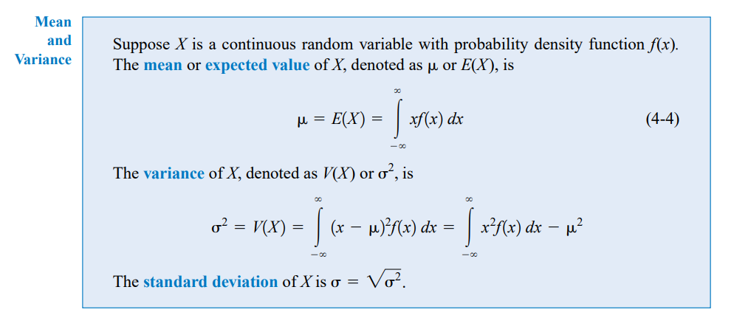

**Áp dụng công thức tính tích phân của X^3/8 từ 0-2**

1. Suppose the probability **density function** of the length of computer cables is [[f (x) =0.5](https://cmshn.fpt.edu.vn/filter/tex/displaytex.php?texexp=f%20%28x%29%20%3D0.5)](https://cmshn.fpt.edu.vn/filter/tex/displaytex.php?texexp=f%20%28x%29%20%3D0.5" \o "TeX)from 10 to 12 millimeters. Determine the mean and standard deviation of the cable length.

Select one:

a. mean = 22 and standard deviation = 0.66

b. mean = 11 and standard deviation = 0.33

c. mean = 22 and standard deviation = 1.16

d. mean = 11 and standard deviation = 0.58

**Mean = tích phân của 0.5x cận 10-12 = 11**

**Std = căn tích phân của 0.5(x-11)^2 cận 10-12 = 0.58**

1. Suppose the **cumulative distribution** of the random variable X is  
   [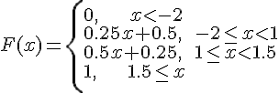](https://cmshn.fpt.edu.vn/filter/tex/displaytex.php?texexp=F%28x%29%20%3D%20%5Cleft%5C%7B%20%5Cbegin%7Barray%7D%7Bl%7D0%2C%5C%20%5C%20%5C%20%5C%20%5C%20%5C%20x%20%3C%20-%202%20%5C%5C%200.25x%20%2B%200.5%2C%5C%20%5C%20-%202%20%5Cle%20x%20%3C%201%20%5C%5C%200.5x%20%2B%200.25%2C%5C%20%5C%201%20%5Cle%20x%20%3C%201.5%20%5C%5C%201%2C%5C%20%5C%20%5C%20%5C%20%5C%20%5C%201.5%20%5Cle%20x%20%5C%5C%20%5Cend%7Barray%7D%20%5Cright.)  
   Detemine [P(X<-1\,\, or\,\, X > 1.6)](https://cmshn.fpt.edu.vn/filter/tex/displaytex.php?texexp=P%28X%3C-1%5C%2C%5C%2C%20or%5C%2C%5C%2C%20X%20%3E%201.6%29)

Select one:

a. 0.16

b. 0.29

c. 0.25

d. 0.47

**Nó bảo tính 1 trong 2 vế mà với x>1.6 không có đáp án nào là 1 nên ta chỉ tính x<-1**

**P(x<-1)=0.25*-2+0.5=0.25**

1. The probability **density function** of X, the lifetime of a certain type of electronic device (measured in hours), is given by [[f(x)=\frac{10}{x^2},x>10.](https://cmshn.fpt.edu.vn/filter/tex/displaytex.php?texexp=f%28x%29%3D%5Cfrac%7B10%7D%7Bx%5E2%7D%2Cx%3E10.)](https://cmshn.fpt.edu.vn/filter/tex/displaytex.php?texexp=f%28x%29%3D%5Cfrac%7B10%7D%7Bx%5E2%7D%2Cx%3E10." \o "TeX)Determine the value of [F(20).](https://cmshn.fpt.edu.vn/filter/tex/displaytex.php?texexp=F%2820%29.)

Select one:

a. 0.2

b. 0.6

c. 0.9

d. 0.5

**Tính tích phân từ 10-20 của fx**

**Dạng 2**

1. Let *X* be a **uniform random** variable over the interval [0, 8] . What is the probability that the random variable *X* has a value greater than 3?

Select one:

a. 0.575

b. 0.500

c. 0.625

d. 0.750

**Bấm máy 1/(8-0) * (3-0) = 0.375 do lấy lớn hơn 3 nên 1-0.375 =0.625**

1. Suppose a **uniform random** variable can be used to describe the outcome of an experiment with outcomes ranging from 41 to 81. What is the probability that this experiment results in an outcome less than 56?

Select one:

a. 0.250

b. 0.375

c. 0.312

d. 0.080

**Bấm máy 1/(81-41) * (56-41) =0.375**

1. The diameters of ball bearings produced in a manufacturing process can be described using a **uniform distribution** over the interval 8.5 to 10.5 millimeters. What is the probability that a randomly selected ball bearing has a diameter greater than 9.8 millimeters?

Select one:

a. 0.650

b. 0.876

c. 0.350

d. 0.484

**1/(10.5-8.5) * (9.8-8.5) = 0.65 do lấy lớn hơn 9.8 nên 1-0.65 = 0.35**

1. Let *X* be a random variable has the following **uniform density** function f(x) = 0.1 when 0< x < 10. What is the probability that the random variable *X* has a value greater than 5.3?

Select one:

a. 0.28

b. 0.49

c. 0.47

d. 0.21

1. Suppose a **uniform random** variable can be used to describe the outcome of an experiment with the outcomes ranging from 30 to 80. What is the probability that this experiment results in an outcome less than 45?

Select one:

a. 0.20

b. 0.30

c. 0.09

d. 0.29

1. A machine is set to pump cleanser into a process at the rate of 5 gallons per minute. Upon inspection, it is learned that the machine actually pumps cleanser at a rate described by the **uniform distribution** over the interval 4.5 to 7.5 gallons per minute. Find the probability that between 4.8 gallons and 6.2 gallons are pumped during a randomly selected minute.

Select one:

a. 0.47

b. 0.84

c. 0.33

d. 1

1. The diameters of ball bearings produced in a manufacturing process can be described using **a uniform distribution** over the interval 4.5 to 7.5 millimeters. Any ball bearing with a diameter of over 6.25 millimeters or under 4.55 millimeters is considered defective. What is the probability that a randomly selected ball bearing is defective?

Select one:

a. 0

b. 0.250

c. 0.433

d. 0.505

**Do đề hỏi defective nên lấy 1 – kết quả của bấm máy**

1. A machine is set to pump cleanser into a process at the rate of 10 gallons per minute. Upon inspection, it is learned that the machine actually pumps cleanser at a rate described by the **uniform distribution** over the interval 9.75 to 11.25 gallons per minute. What is the probability that at the time the machine is checked it is pumping more than 10.65 gallons per minute?

Select one:

a. 0.50

b. 0.25

c. 0.40

d. 0.66

**Dạng 3**

1. A bank's loan officer rates applicants for credit. The ratings are **normally distributed** with a mean of 350 and a standard deviation of 50. If an applicant is randomly selected, find the probability of a rating that is between 310 and 295.

Select one:

a. 0.0668

b. 0.0762

c. 0.9032

d. 0.4332

**Bấm máy : mode 3 ac + shift 1 5 1 nhập p((310-350)/50) – p((295-310)/50) = 0.0762**

1. A machine pours beer into 16 oz. bottles. Experience has shown that the number of ounces poured is **normally distributed** with a standard deviation of 1.2 ounces. Find the probabilities that the amount of beer the machine will pour into the next bottle will be between 12.5 and 14.5 ounces.

Select one:

a. 0.1039

b. 0.1831

c. 0.088

d. 0.4281

**Tương tự câu trên**

1. The systolic blood pressure of 18-year-old women is **normally distributed** with a mean of 110 mmHg and a standard deviation of 10 mmHg. What percentage of 18-year-old women have a systolic blood pressure that lies within **3 standard deviations** of the mean?

Select one:

a. 95.%

b. 99.99%

c. 99.7%

d. 68%

**1:68,7**

**2:95.45**

**3:99.7**

1. Suppose that prices of a certain model of new homes are **normally distributed** with a mean of $150,000. Find the percentage of buyers who paid between $148,885 and $151,220 if the standard deviation is $1250.

Select one:

a. 99.7%

b. 95.6%

c. 64.9%

d. 68.1%

1. The weekly salaries of elementary school teachers in one state are **normally distributed** with a mean of $595 and a standard deviation of $43. What is the probability that a randomly selected elementary school teacher earns more than $555 a week?

Select one:

a. 0.2823

b. 0.8239

c. 0.2177

d. 0.7123

**Lớn hơn lên lấy 1-P((555-595)/43)**

1. The tread life of a particular brand of tire is a random variable best described by a **normal distribution** with a mean of 60,500 miles and a standard deviation of 2800 miles. What is the probability a particular tire of this brand will last longer than 58,400 miles?

Select one:

a. 0.8413

b. 0.2266

c. 0.7734

d. 0.1541

**Tương tự câu trên**

1. Assume that the weights of quarters are **normally distributed** with a mean of 5.73 g and a standard deviation 0.071 g. A vending machine will only **accept** coins weighing between 5.48 g and 5.82 g. What percentage of legal quarters will be **rejected**?

Select one:

a. 10.27%

b. 1.96%

c. 62.54%

d. 2.48%

**Do đề hỏi reject lên 1-(P((5,82-5.73)/0.071)- P((5,48-5.73)/0.071))=0.1026**

**Dạng 4:**

**The number of ounces of soda that a vending machine dispenses per cup is normally distributed with a mean of 14 ounces and a standard deviation of 4.2 ounces. Find the number of ounces above which 98% of the dispensed sodas will fall.**

**Let P(Z < -2.05) = 0.02, P(Z < 0) = 0.5.**

Select one:

a. 5.4

b. 7.8

c. 6.1

d. 7.4

**The number of ounces of soda that a vending machine dispenses per cup is normally distributed with a mean of 12.4 ounces and a standard deviation of 4.3 ounces. Find the number of ounces above which 86% of the dispensed sodas will fall.**

Select one:

a. 9.1

b. 12.4

c. 7.8

d. 8.6

**The owner of a fish market determined that the weights of catfish are normally distributed with the average weight for a catfish is 3.2 pounds with a standard deviation of 0.6 pound. A citation catfish should be one of the top 5% in weight. At what weight (in pounds) should the citation designation be established?**

Select one:

a. 4.84

b. 2.21

c. 7.85

d. 4.19